Usability Question: How to add a friend using the scan QR code.

At the right corner side as you can see have a scanner. User can click the icon. User can use the scanner to scan QR code.

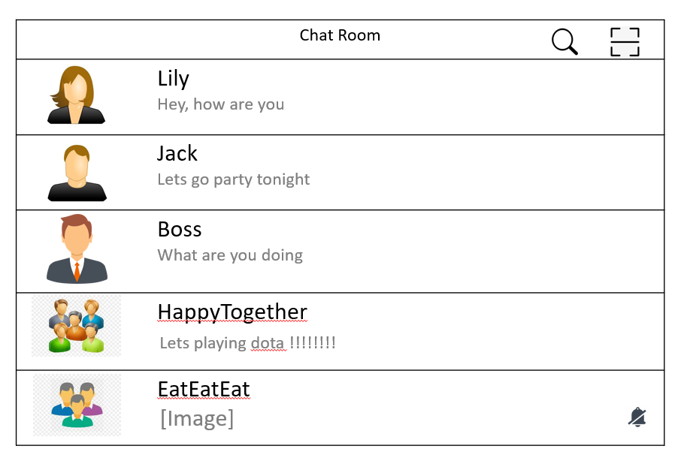

How the user knows the friend that want to add QR code. The user can ask the friend open the user profile. It will show like figure below. At the last row, as you can see have QR code. User can ask the friend click in.

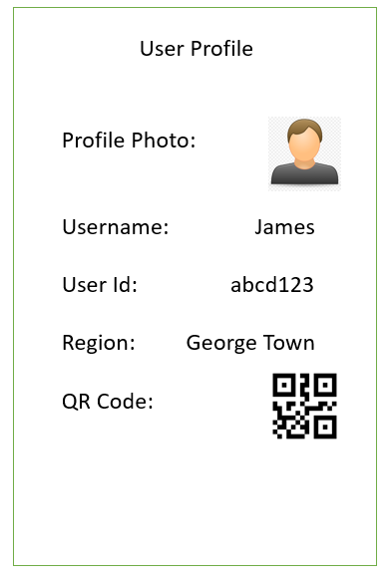

After the friend click in, the friend will see the figure below. So that the user can use the scanner to scan the QR code as below.

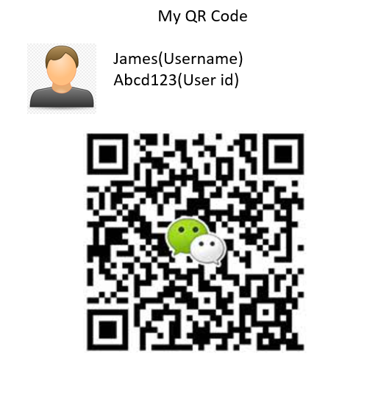

After the user click the scanner it will show the figure as below. User must scan the QR code inside the box. If the user did not scan the QR code inside the box, the scanner will do not detect to the QR code , it will display error notice.

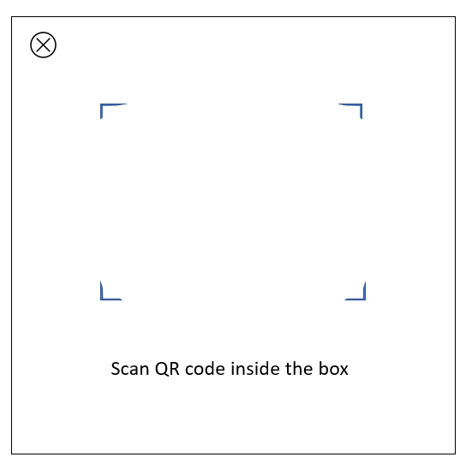

Usability Question: How the user comment on the other user post.

The figure below is the friend list of the user. As you can see on the right-hand side, user can choose the first alphabet at the beginning of the names of friends so that users can find the friends they are looking for faster on the friend list. Example the user wants to comment on the friend name as jack. The user can select on the jack name.

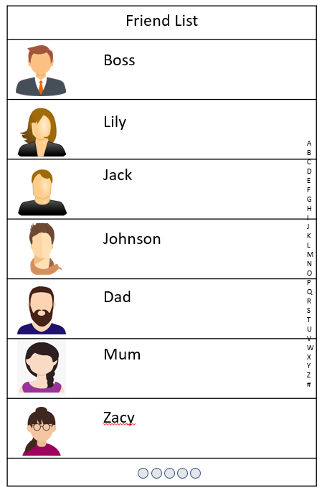

After the user select the jack name, it will display as the figure on below. As you can see on the jack’s profile has show username, user id, moments, send message and voice call/ video call. The user want to comment on the friend’s post just click the moments.

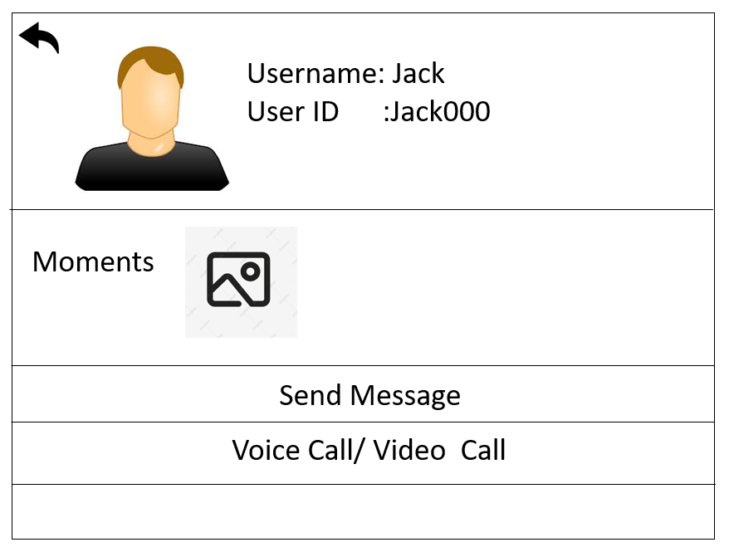

The figure show below is when the user click the moment of the friend profile. In the figure at below, it has the wallpaper , username and post. On the post there has show like and comment button. The like button is for user to like the friend post and comment button is allow the user to comment friend post.

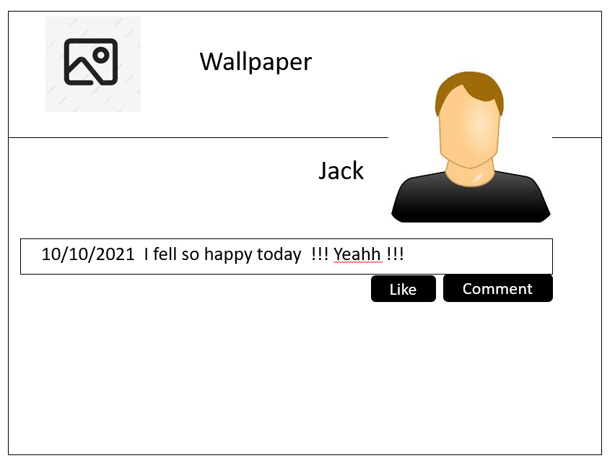

After click the comment button, it will display a text box. The user just types the content that want to comment to friend’s post inside the text box. When the user finish types the content, just click the enter ok button at the right corner side inside the text box.

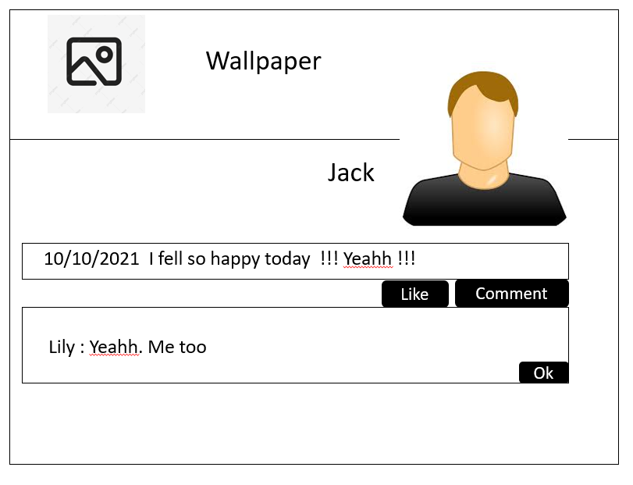

After the user click the ok button. The word that user type just now will show at the below of the friend post and its will also show the user name and the comment time.

